Using a Biomek 2000 Basic Use and Writing an Assay
Thomas Hunt
What you need:
- A Biomek 2000
- A Computer that uses Windows XP
  - Windows 7 has worked but can behave erratically
  - Anything more advanced will confuse the Biomek 2000
- A double female RS232 Cable
- A power cable
- The Bioworks program installed on your Windows XP
The Tools on Bioworks

- Workstation Server: connects the Biomek 2000 to the computer. This program must be on to activate the Biomek.


- Edit: Use this program to edit or create a new procedure


- Lab Book Manager: The Lab Books act as folders for Biomek assays in Bioworks. You can save your assays in different lab books to keep them managed. This tool allows you to sort or select a Lab Book


- Diagnostics: This program helps fix the Biomek 2000 on occasion. Over time the Biomek may lose accuracy. An occasional adjustment helps the Biomek maintain accuracy.


- Run: Selects the assays from edit and runs them


- BioScript: Allows you to move the Biomek Freely, and even record its movements. These recordings can be run again and even inserted into assays. You can use these custom movements for specialized processes in automation

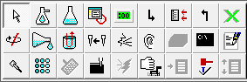
1
2
3
4
5
6
7
8
9
10
11
12
13
14
15
16
17
- Pointer
- Aspirate
- Purge
- Pause System
- Pause Labware
- Begin Loop
- End Loop
- Mix
- Bulk
- Wash
- Change Tips
- Comment
- Pipette
- Serial
- Reset Tip
- Move Labware
- Bioscript

Commence the Automation!

Getting the Biomek 2000 to communicate with the Computer
- Install Bioworks onto your computer
- Give the Biomek 2000 a power source with the power cable
- Connect the Biomek 2000 and the computer with the RS232
  - Any of the RS232 ports will work, but I’d recommend using Port 1
- Pull up your Bioworks folder on your computer, you will see a program called Workstation Server
- The Workstation Server reports the state of the Biomek 2000 connection
  - Be sure to pull this program up first!
  - If the RS232 cable is plugged into your computer, the workstation server will claim its state is “Receive Biomek”
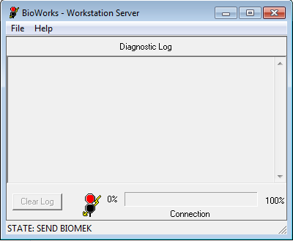
  - Once the Biomek is on and connected to the computer, the computer will begin connecting channels
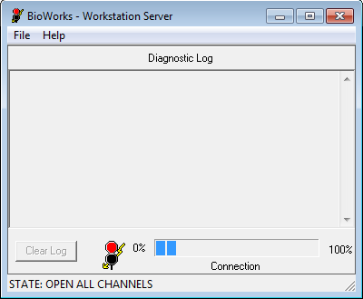
  - Until the Workstation Server looks like this
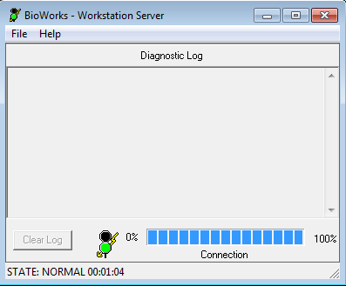
  - The Biomek 2000 is now able to perform your procedure!
- To Create a procedure, pull up the Edit program
- To write a new program click the icon new and select clear configuration.
Creating a new assay and filling the worksurface
- The first thing to creating an assay is filling the Worksurface with labware on the edit program.
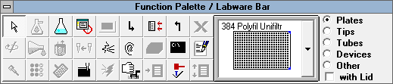
- You can select labware for the worksurface or actions for the assay here.
- You can set up the deck to be anything you want, however, I recommend following this configuration if possible, to avoid confusion and unneeded adjustments to the Biomek 2000 deck
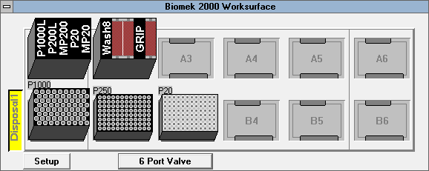

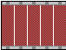
- Note! This icon in the Labware bar is the same as this icon in the worksurface. This icon has just been filled with tools.

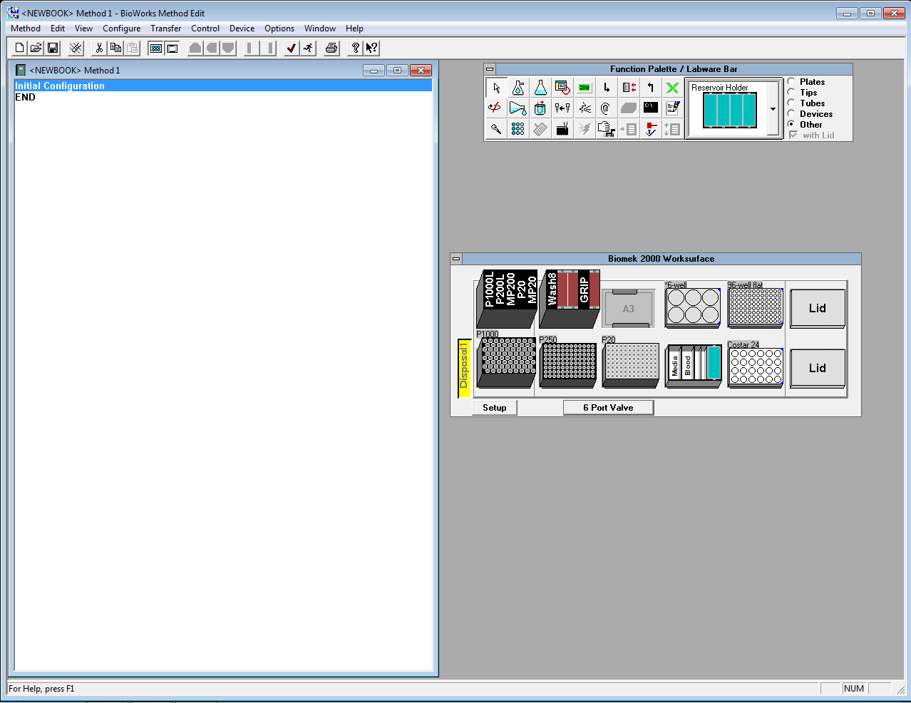
- All labware is found on the Labware Bar. The tool rack and Reservoir holder have a separate window that allows you to specify the items in them
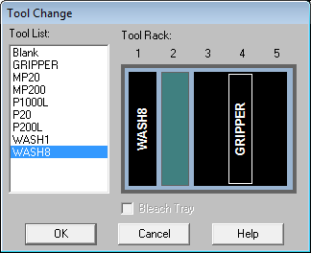
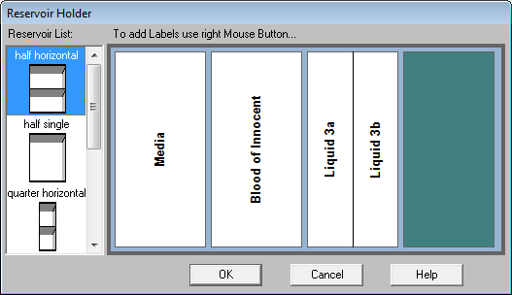
- Now you have filled your worksurface with tools, you can begin creating actions.
Writing actions
- Actions form the code that will constitute your assay
- The actions will be listed on the method window to the left of the worksurface.
- The following is a list of actions you can use that will help you write an assay
Move labware
- To use the gripper, select the “move labware” Icon, then click the labware you want to move and then click its destination
  - If there is a lid on the labware, a window will come up, asking if you want to move the whole plate or just the lid
  - Be sure that initial configuration is not selected when you use “move labware” otherwise, the action will not be coded
Pipetting
- To add a pipette action click pipette, click the plate you want to aspirate first then click the plate you want to dispense.
  - Make sure the labware you selected does not have a lid on it, or the pipetting won’t work
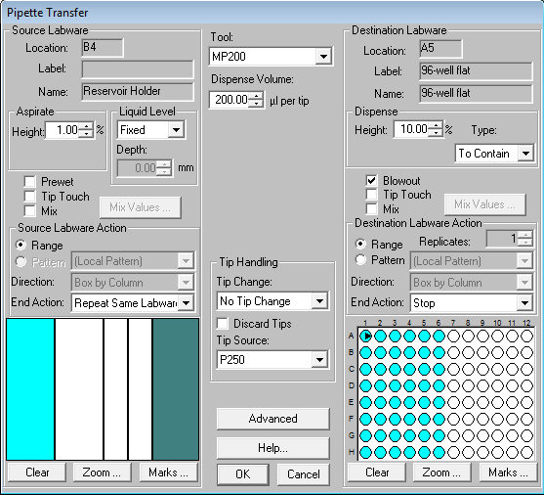
- There are a series of settings that define the pipette
- Select the tool you will use, this will change the volume available and whether or not the pipette is a multipipette
- Select a pattern of pipetting by highlighting the wells on the source and destination labware
  - You can select columns rows or other patterns to define this.
  - Important! The pipetting will initially be stopped once it has run through a well, if you want to reuse one well, select the end action for that well to be “Repeat Same Labware.” This will repeat the given well(s) until all the wells on the other plate have been used.
- Now, you can select the volume the pipette will aspirate and dispense
  - If you are using a multipipette, the volume is defined as the volume per pipette, not the total volume
Aspirating
- Aspiration uses the WASH-8 tool, which hooks up to the wash unit, instead of the arm.
  - Important! If you want to use aspiration, turn on the vacuum before starting the assay, unlike the dispenser, the aspiratior gains its suction from an outside suction, instead of the wash unit.
- To aspirate an item, click the aspiration button, several of the parameters are identical to that of the pipetting.
- We only have a WASH8 tool, meaning the wash unit can only effectively aspirate and dispense on plates with columns of 8
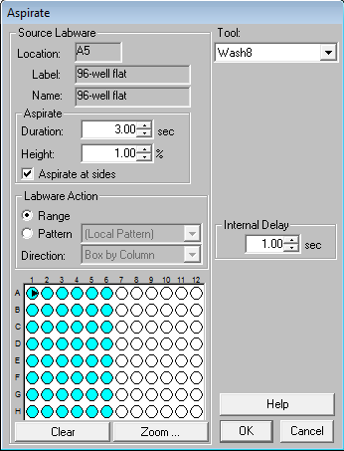
- There is no volume measured for aspiration, only a duration for aspiration. I have found 3 seconds should be sufficient for a 96 well plate column
- Select the option of aspirating at the sides
  - It looks jerky forceful at glance, but I have not noticed any major damage to the plate or WASH-8 when done.
  - Aspirating at the sides has proven to be the most effective method of removing all liquid from a well
- The internal delay creates pauses between aspiration, I leave 1 second
Bulk Dispense
- Dispensing uses the wash unit to dispense liquid, like aspiration, it uses tubing and a suction source not on the arm.
  - It is most effective at dispensing high quantities of liquid quickly, at the cost of accuracy. Actions like PBS washes are ideal for the Wash unit.
- To dispense an item, click the dispense button, several of the parameters are identical to that of the pipetting and aspirating.
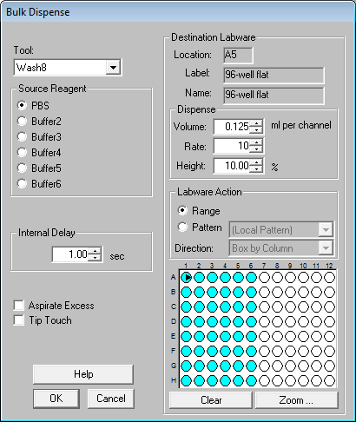
- Unlike aspiration, you can define a volume for the dispense, it will be less accurate than pipetting, but a lot faster
- The rate defines how quickly the liquid is dispensed. You can make the dispensing process quick or gentle, if you have delicate samples on the plate.
- Pause System
- During assays, it will become necessary to pause the assay to allow the sample to incubate. Pause system allows you to stop the Biomek.
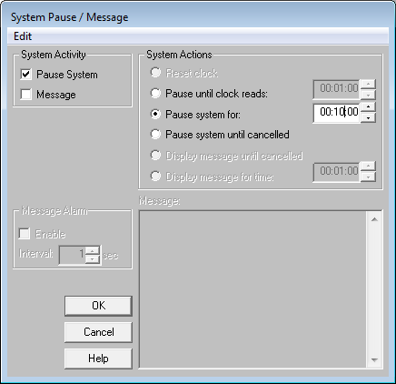
- There are 3 pause options
  - Pause until clock reads:
    - There is a “clock” that measures how far into the assay the process is, this clock therefore defines when the system will restart
  - Pause system for:
    - The system will pause for any set time
  - Pause system until cancelled
    - The system will pause until you cancel it on the computer
Comments
- Once an assay is written, it can be confusing to go back and determine what happened. Comments allow you to write comments to remind you and others what is happening where during the process. It is totally optional, but I recommend it for clarification.
Begin and End Loops
- If you want to repeat the same action multiple times, without the extra lines, insert the begin loop just before the action(s) and the end loop just after
- The begin loop will ask you the number of times you want to repeat the action
BioScript
- BioScript is a specialized action for the Biomek, unlike other actions, BioScript grants complete power to the user. You essentially write exactly where the Biomek arm moves this is helpful for specialized tasks
- I will cover how to write BioScript in a different document. Here I will describe how to instert BioScript into your assay code
- To insert BioScript, click insert BioScript and select your saved code
  - The Biomek 2000 cannot pick up a tool in BioScript to substitute for this, make sure you add an action just before the BioScript is activated so the Biomek 2000 has just used the tool you want on the arm.
  - Important! When performing other actions, the Biomek knows where tools are, and can avoid collision based on this knowledge. It does not have sensors! When using BioScript make sure the movements take into consideration the equipment that will be on the biomek and test several times before actually inserting into the assay.

